

Course Name: software Project ll

Course Code: CSE236

Software Requirement Specification

On

Library Management System

**Version: 2**

Submitted to:

Name: Golam Rabbany

Lecturer, Daffodil International University

Department: CSE

Submitted by:

Name: Md Harunur Rashed

ID: 221-15-5742

Department: CSE

Section: 61_U

Date of Submission: 08-11-2023

SRS for Harun Page |i

# Table of contents

**Table of Contents i**

**List of Figures ii**

1. **Introduction**
2. **Methodology 1**
   1. Purpose 1
   2. Project Scope 1
   3. Glossary …….1
   4. Overview 2
3. **User Classes and Characteristics 3**
4. **Design and Implementation Constraints 3**
   1. User Interface Technology 3
      1. Programming Language 3
      2. JavaScript and jQuery Library 3
      3. CSS Framework 4
   2. Implemented Tools and Platform 4
      1. Web Server 4

1.1.1 Database Server 4

1. **Requirement Specification 5**
   1. Functional Requirements 6
   2. Performance Requirements 7
      1. Capacity Requirements 7
   3. Dependability Requirements 8
      1. Reliability and Availability 8
      2. Robustness and Fault Tolerance Requirements 8
      3. Safety Critical Requirements 8
   4. Maintainability and Supportability 8
      1. Maintenance Requirements 9
      2. Supportability Requirements 9
      3. Adaptability Requirements 9
   5. Security Requirements 9
      1. Access Requirements 10
      2. Integrity Requirements 10
      3. Privacy Requirements 10
      4. Ease of Use Requirements 10
      5. Understand-ability and Politeness Requirements 11
      6. Accessibility Requirements 11
      7. User Documentation 12
   6. Operational and Environmental Requirements 12
      1. Expected Physical Requirements 12
      2. Requirement for Interfacing with Adjacent System 12
      3. Release Requirements 13
   7. Legal Requirements 13
      1. Compliance Requirements 13

## 1. Introduction

The introduction of the Software Requirements Specification (SRS) provides an overview of the entire SRS with purpose, scope, definitions, acronyms, abbreviations, references and overview of the SRS. The aim of this document is to gather and analyze and give an in-depth insight of the complete **Library Management System** by defining the problem statement in detail. Nevertheless, it also concentrates on the capabilities required by stakeholders and their needs while defining high-level product features. The detailed requirements of the **Library Management System** are provided in this document.

1. **Methodology**

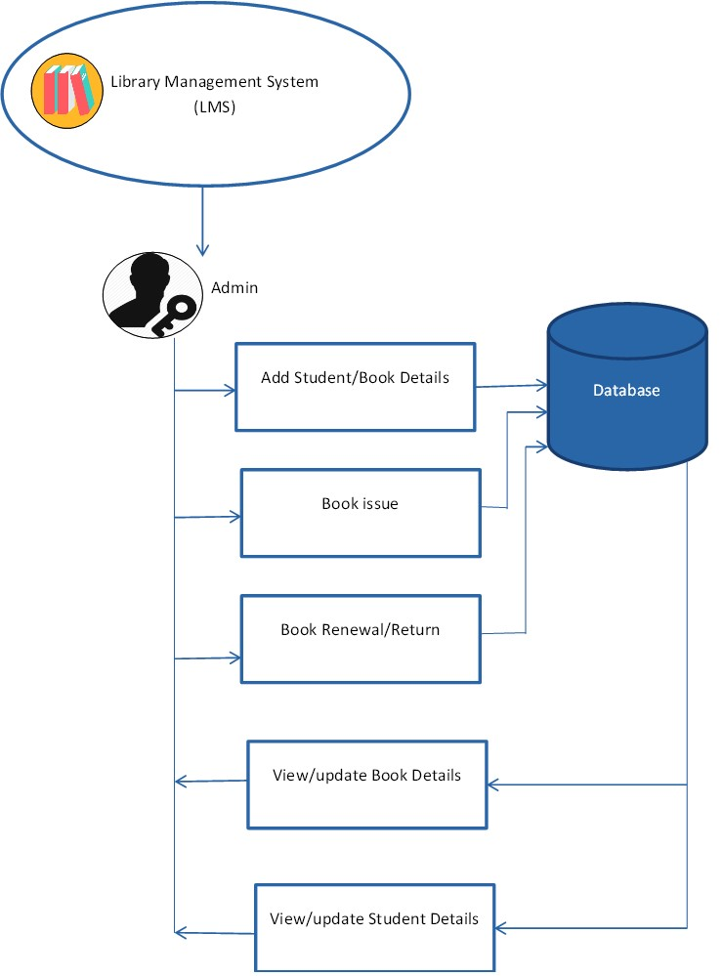

### 1.1 Purpose

The purpose of the project is to maintain the details of books and library members of different libraries. The main purpose of this project is to maintain a easy circulation system between clients and the libraries, to issue books using single library card, also to search and reserve any book from different available libraries and to maintain details about the user (fine, address, phone number). Moreover, the user can check all these features from their home

### 1.2 Project Scope

* Manually updating the library system into an android based application so that the user can know the details of the books available and maximum limit on borrowing from their computer and also through their phones.
* The ILM System provides information's like details of the books, insertion of new books, deletion of lost books, limitation on issuing books, fine on keeping a book more than one month from the issued date.
* Also, user can provide feedback for adding some new books to the library.

### 1.3 Glossary

This subsection contains definitions of all the terms, acronyms, and abbreviations used in the document. Terms and concepts from the application domain are defined.

* LMS –Library Management System
* SRS – System Requirement Specification
* SDLC – Software Development Life Cycle
* UI – User Interface

#### 1.5 Overview

The goal of this project is to provide simplicity as well as security and efficiency to the Management of Agape Youth Library and also to reduce the management personal in the library.

Library Management System is a project which aims to develop a computerized system. The system helps both students and the library manager to keep track of all books available in the library. It allows both the admin and the student to search for the desired book.

The main feature of this system is that all books available in the library can be displayed in a list so that students need not roam through the entire library to find a book. Additionally, the System effectively maintains the users of the students / students whose books have been issued; It also records the issued date and return date.

## 2. User Classes and Characteristics

There are three types of users in this system. The first two are, Admin, and Librarian, the only distinction between them is that Admin are allowed to see the preference and exclusion sets of other users. It is the third type of user, the administrator, who is able to initially setup the system, add new users, and set their authorization level.

**Users:** Most members will be of the type users. They also can see all the admin members’ associates to this system. They also can get the admin card facilitates.

**Librarian:** The next most common type of user is the authorized Librarian. These users have the same permissions as the general members with the additional ability to view other member’s preference and exclusion set. They are allowed to post events notice even they also can post job circular for general Librarian’s. Also, they have the permission to change their profile.

**Admin:** Finally, the system administrators are users who are able to setup the system from the initial installation and maintain the systems member accounts. They automatically have the functionality of authorized users within the normal operation of the system; however, have additional menu options which allow them to maintain the system.

### 3. Design and Implementation Constraints

Design and implementation constraints are those that we have used to implement this project make successful. It also describes tool that enables developers and testers to view and interact with the user interface (UI) elements of this application.

### 3.1 User Interface Technology

User interface (UI) is everything designed into a system view that which person’s associates with this system may like the interface of this system.

#### 3.1.1 Programming Language

For developing this system, we will use PHP as a programming language. PHP (recursive acronym for *PHP: Hypertext Pre-processor*) is a widely-used open-source general-purpose scripting language that is especially suited for web development and can be embedded into HTML. PHP is a server scripting language, and a powerful tool for making dynamic and

interactive Web pages

#### 3.1.2 JavaScript and jQuery Library

The most common use of JavaScript is to add client-side behavior to HTML pages, also known as Dynamic HTML (DHTML). Scripts are embedded in or included from HTML pages and interact with the Document Object Model (DOM) of the page.

jQuery is a JavaScript library. jQuery greatly simplifies JavaScript programming. jQuery UI is a curated set of user interface interactions, effects, widgets, and themes built on top of the jQuery JavaScript Library. Whether you're building highly interactive web applications or you just need to add a date picker to a form control, jQuery UI is the perfect choice. jQuery UI is built for designers and developers alike. We've designed all of our plug-ins to get you up and running quickly while being flexible enough to evolve with your needs.

#### 3.1.3 CSS Framework

CSS is a language that describes the style of an HTML document. CSS describes how HTML elements should be displayed. Build responsive, mobile-first projects on the web with the world's most popular front-end component library.

Bootstrap is an open-source toolkit for developing with HTML, CSS, and JS. Quickly prototype your ideas or build your entire app with our Sass variables and mix INS, responsive grid system, extensive prebuilt components, and powerful plug-ins built on jQuery.

The bootstrap code is included minified, which means that white spaces are removed to make the file size smaller and therefore make the load time faster for the file which improves the load time for the whole page. The main design that bootstraps ads without specifically adding design to elements is that when hovering over a link. This is fixed with some simple CSS code added to the CSS-file, unless the bootstrap CSS-file is included after the original, then bootstrap will override the custom ones and the changes will not be seen. Having some basic knowledge about how Bootstrap works before starting to use it would increase the efficiency and speed one might achieve the goal one has in mind for including bootstrap into the project.

#### 3.2 Implemented Tools and Platform

Every business plan, campaign, or project comes down to Tactics, Tools, and Strategies. To conceive, develop, and implement a sound social media marketing strategic plan that will be successful needs to have those three critical components.

##### 3.2.1 Web Server

A Web [server](https://whatis.techtarget.com/definition/server) [i](https://whatis.techtarget.com/definition/server)s a program that uses [HTTP](https://searchwindevelopment.techtarget.com/definition/HTTP) (Hypertext Transfer Protocol) to serve the files that form Web pages to users, in response to their requests, which are forwarded by their computers' HTTP clients. Dedicated computers and appliances may be referred to as Web servers as well. We will use the Apache HTTP server to implement this project

##### 3.2.2 Database Server

We will use MySQL database server to store all of the information of this system. The reason behind to choose the database server are given below:

* Security
* Reporting and Data Mining
* Replication
* Fault tolerance
* Performance diagnostics

## Use case Diagram

## 1. Requirement Specification

The complete requirement specification based on the elicitation process is described in this section.

The Functional Requirements Specification is designed to be read by a general audience. Readers should understand the system, but no particular technical knowledge should be required to understand the document.

SRS for LMS Page|5

|  |  |
| --- | --- |
| **FR-01** | **Member Information** |
| **Description** | This module helps admin to register alumni members. Admin is able to maintain all the information of alumni members |
| **Stakeholders** | Admin |
| **FR-02** | **Update Members Details** |
| **Description** | This module helps admin to update alumni members’ information. Admin and alumni members can update the details of the members and we store these details in database. |
| **Stakeholders** | Admin, Alumni member |
| **FR-03** | **Unregistered Members** |
| **Description** | Admin can delete the details of the alumni member and it also deletes these details in database. |
| **Stakeholders** | Admin |
| **FR-04** | **Search Member** |
| **Description** | Admin can search the details of the students and the system displays the specific member |
| **Stakeholders** | Admin |
| **FR-05** | **View Member Details** |
| **Description** | Admin as well as members can view the entire details of the students or members who are registered. |
| **Stakeholders** | Admin, Alumni member |
| **FR-06** | **Post Events and Notice** |
| **Description** | Admin as well as members can post or create any type events and notice that is related to this alumnus. All the members of this alumni can see every event and notice |
| **Stakeholders** | Admin , Alumni member |
| **FR-07** | **Job Posting** |
| **Description** | The executive alumni members can post any job circular news to this alumni system and the members of this system can comment on this job posting and can share the post |
| **Stakeholders** | Admin , Alumni member |
| **FR-08** | **Messaging** |

SRS for LMS Page |6

|  |  |
| --- | --- |
| **Description** | All the registered alumni members can message to each other through this system |
| **Stakeholders** | Alumni members |
| **FR-08** | **Messaging** |
| **Description** | All the registered alumni members can message to each other through this system |
| **Stakeholders** | Alumni members |

## 3.2.1Performance Requirements

A requirement that specifies a performance characteristic that a system or system or system component must possess; for example, speed, accuracy, frequency

### 5.2.1 Capacity Requirements

The system is able to manage all the information of passed out students.

|  |  |
| --- | --- |
| **PR-02** | Initially the system will store 50,000 student information |
| **Description** | The information of Alumni will be stored in database. |
| **Stakeholders** | Admin, Librarian |

### 5.3 Dependability Requirements

The flexibility of current frameworks encourage system architects to enable reconfiguration mechanisms that refocus the available, safe resources to support the most critical services rather than over-provisioning to build failure-proof system. Therefore, these requirements are essentials.

#### 5.3.1 Functional Requirements

The flexibility of current frameworks encourage system architects to enable reconfiguration mechanisms that refocus the available, safe resources to support the most critical services rather than over-provisioning to build failure-proof system. Therefore, these requirements are essentials.

#### 5.3.2 Reliability and Availability

In order to support global and smooth operations the system must be available around the clock. On the other hand most services in this system are not mission-critical. Even better the game posting can handle times of downtime as the users usually interact with highavailability from third party website. This system will be able to catch up with their data once it's up and running again.

|  |  |
| --- | --- |
| **DR-01** | The system must be available 12x7 |
| **Description** | * The system must be available 12 hours in a day * The system must be updated regularly * The system must publish the notice, |
| **Stakeholders** | Admin, Librarian ,Users |

#### *5.3.3 Robustness and Fault Tolerance Requirements*

The system will almost ensure 0% crush in any single minor error and don’t give any wrong calculation.

|  |  |
| --- | --- |
| **DR-02** | The system handles over access and system errors |
| **Description** | Sometimes multiple users can over access to this system. The system can handle multiple user access |
| **Stakeholders** | N/A |

**5.3.4 Safety Critical Requirements**

There are no specific safety critical requirements

### 5.4 Maintainability and Supportability

Supportability is the degree to which system design characteristics and planned logistics resources meet system requirements. Supportability is the capability of a total system design to support operations and readiness needs throughout the life-cycle of a system at an affordable cost.

#### 5.4.1 Maintenance Requirements

|  |  |
| --- | --- |
| **MS-01** | The system helps to update any information in any time |
| **Description** | The admin and Librarian can post any events and can enable to change or update any information in any situation |
| **Stakeholders** | Admin, Librarian,Users |

#### 5.4.2 Supportability Requirements

In order to understand the system's behaviour on a technical support required by the system operator. The reason for reading them might be

* System malfunction has occurred and the system operator has to find the exact point of time when this happened
* System produces wrong results and the developers must be able to reproduce the data flow through the system
* Hacker tried to breach the system's security mechanisms and the system operator must understand what he did

**5.4.3 Adaptability Requirements**

There are no specific adaptability requirements

### 5.5 Security Requirements

There are no access requirements beside those that have been outlined in the below:

* The software must validate all user input to ensure it does not exceed the size specified for that type of input
* The server must authenticate every request accessing the restricted Web pages
* After authenticating the browser, the server must determine whether that browser is authorized to access the requested restricted Web pages
* The system must have security controls to protect against denial-of-service attacks
* The system must encrypt sensitive data transmitted over the Internet between the server and the browser

To get access to this system or a specific module the system must provide a central authentication mechanism. In order to prevent anyone to exploit stolen all users password must

SRS for LMS Page |9

#### 5.5.1 Access Requirements

To get access to the system, the system provides authorization/authentication way. This system uses various modules.

|  |  |
| --- | --- |
| **SR-01** | The system provides security strategies. |
| **Description** | The system is designed in way that allows all modules to access a mechanism that provides security services. |
| **Stakeholders** | Admin, Librarin , Users |

#### 5.5.2 Integrity Requirements

To protect credentials of user from being stolen, all passwords are stored in encrypted form. The Requirements significantly reduces the value of stolen user credentials, it’s not easy to decrypt the password.

#### 5.5.3 Privacy Requirements

The system provides a protection of the database in the server. However, the system will have to increment this level of protection because of the personal data mode available on the system & the larger share of people that will be having access to it through the system’s registration. The user’s privacy will be granted by the limited access that the log in process is going to give to the database.

|  |  |
| --- | --- |
| **SR-02** | All data will be protected |
| **Description** | The main requirement in the context is the generation of Alumni member’s data for analysis. |
| **Stakeholders** | Admin, Librarin , Users |

### 5.6 Usability and Human Integrity Requirements

These Requirements define how to meet the physical and cognitive needs of the intended users of your website or application

#### 5.6.1 Ease of Use Requirements

The system is easy to use and can easily be understandable.

SRS for LMS Page |10

|  |  |
| --- | --- |
| **UH-01** | The system must be usable for Librarin , Users with all associate stakeholders. |
| **Description** | The system indicates the several possibilities that the Librarin , Users has to go on in using the system. The alumni members are allowed to undo any of the operation. |
| **Stakeholders** | Admin, Librarin , Users |

#### 5.6.2 Understand-ability and Politeness Requirements

This section describes more requirements of DIU Alumni system to add more features in future

|  |  |
| --- | --- |
| **UH-02** | The features Library Management System |
| **Description** | The system is more efficiently ease of use more added features .The system is understand-ability for both user. The system will not use any term that is not specified in this system. |
| **Stakeholders** | Admin |

##### 5.6.1 Accessibility Requirements

We have 3 levels

**User module:** In the user module, user will check the availability of the books

Issue Book

Reserve book

Return book

Fine details

## Library module

* Add new book
* Remove books
* Update details of book

SRS for LMS Page |11

**Administration module:**

The following are the sub module in the administration module :

* Register user
* Entry book details
* Book issue

To get access to this system or a specific module the system must provide a central authentication mechanism. In order to prevent anyone to exploit stolen all users password must be encrypted in hash process.

### 5.6.2 User Documentation

|  |  |
| --- | --- |
| **UH-03** | The system developer documentation |
| **Description** | To develop this project we have specified requirement of user documentation. The teams are involved to this project documentation. |
| **Stakeholders** | System Developer |

### 5.8 Operational and Environmental Requirements

This Requirements focus on how the users will operate the system, including interfaces and interoperability with other systems. The requirements establish how well and under what conditions the system must perform.

**5.8.1 Expected Physical Requirements**

There are no specific expected physical requirements

**5.8.2 Requirement for Interfacing with Adjacent System**

There is no specific interfacing with adjacent system requirements

#### 5.8.3 Release Requirements

There are no specific release requirements but in the project schedule section it was described briefly.

SRS for LMS Page |12

### 5.9 Legal Requirements

These requirements consider any violence of rules and regulation and which rules should be followed to maintain this system.

**5.9.1 Compliance Requirements**

There are no specific compliance requirements